
Scottish Borders Area Command
The Lothians and Scottish Borders

Tweeddale East and West Community Councils
Multi Member Ward Report for August 2022

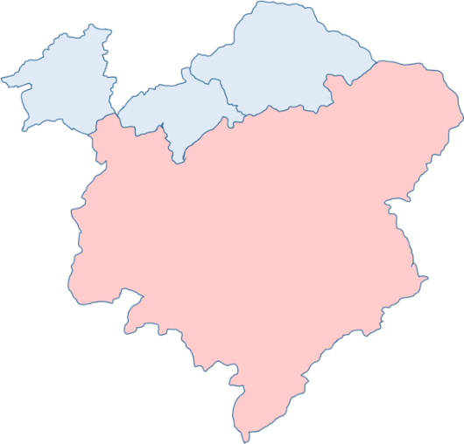

The information provided within this report, is predominately based on the Tweeddale East & West Multi Member Ward Policing Plan and the areas you have identified as priorities.

The data provided in this report is for information purposes only and is not official crime statistics. Due to delayed reporting or recording of crimes, incidents or road accidents and the management of crime enquiries, there is likely to be differences between the information in this report and the final Police Scotland statistics. It would not be appropriate to refer to, quote or use any data in this report as official statistics.
Community Sergeant Update
PS Corrinne Bird
Policing within the communities that many of us not only work but live in, greatly assists the motivation and passion to ensure positive changes are happening. We are currently holding a recruitment drive to encourage residents within the Scottish Borders to consider the police as a career choice, giving back to communities in and around the area. There are online recruitment events being held which will give people an insight into the application and training process as well as a better understanding of the role of a police officer.
Anyone that may be interested in participating in one of these events can request an invite by emailing recruitmentpositiveactiobteam@scotland.police.uk for further information.
This past month has seen children and young people return to schools and college following the end of the summer holidays. Although this is an exciting time for most as they return to new challenges and friend groups, for other young people and their families it can be a daunting time for a number of reasons.
To help assist parents and care givers alleviate the stresses and worries that their children may have, “Togetherall” has an online group specifically for people to share their concerns, experiences and provide an open space to discuss and support one another. This online community can be accessed for free at www.togetherall.com
In line with mental health and well-being, we are aware that World Suicide Prevention Day is approaching on September 10th. Suicides unfortunately continue to be a common part of policing and therefore we are all too aware of the devastating impact it has on so many people.
United to Prevent Suicide encourages organisations to sign up and help work on the movement to change suicide and the stigma that can be associated with it. Due to young males being one of the most high-risk groups, I am looking to request support from the town’s football and rugby clubs in particular during this campaign, which the movement encourages through their “FC United to Prevent Suicide”. This would be to help advertise awareness of the day, encourage open conversations and signpost people to the help that they may need. I would welcome any other suggestions of how we could highlight this day of action around the communities.
We are still encouraging the public to take part in the Your Police Survey 22/23. A reminder to please continue to encourage as many members of the community to complete this as possible.
https://consult.scotland.police.uk/strategy-insight-and-innovation/your-police-2022-2023/
The below link gives access to the latest Scrutiny panel document for the Police, Fire and Rescue and Safer Communities Board, which sits every quarter at Scottish Borders Council.
Item No. 5 a ii - Scottish Borders Scrutiny - Q1 2022-23.pdf (moderngov.co.uk)

This document reporting on progress reports and updates on service matters from Police Scotland as presented by the Local Area Commander CI Vinnie Fisher.

Local Policing Priorities
- Protecting most vulnerable
- Reducing violence and Anti-Social Behaviour
- Reducing acquisitive crime
- Improving road safety
- Tackling serious and organised crime


Protecting most vulnerable

In August 2022 Police in the Scottish Borders attended and were involved with around 170 mental health related calls, around 36 missing person enquiries and approximately 91 domestic related incidents.

Tweeddale East and West had 31 mental health related calls and 1 missing person enquiries. Due to GDPR and protection of victims/subjects involved, we are unable to share any more specific information in relation to these type of call within this report.

Police Scotland work in collaboration with key partners to assist the most vulnerable within the communities and to provide support.

Reducing Violence and Anti-Social Behaviour

Assaults

20/08/22 report received regarding an assault which occurred on Kingsmeadows Road, Peebles between a motorist and a cyclist.

Anti-Social Behaviour

05/08/22 report of youths making a noise and playing music on Tweed Green. Officers unable to attend due to dealing with higher graded calls. No further complaints were received.

05/08/22 report of males acting aggressively at a property in Glensax Road, Peebles. Officers attended and one male arrested for Breach of the Peace and reported for summons.

07/08/22 report of youths causing a nuisance on Tweed Green, Peebles. Officers attended and found no evidence of Anti-Social Behaviour. The youths engaged with the officers and moved on when requested.

13/08/22 report of youths playing loud music on High Street, Peebles. Officers attended and moved the youths on.

15/08/22 report received of an incident involving youths in Dovecot Road, Peebles. Further enquiries being made.

20/08/22 report of youths within grounds of First Nursery, Peebles causing a nuisance. Officers attended and spoke to youths. No damage found.

Vandalism

Between 2300 29/07/22 and 0730 30/07/22 a bench was stolen from a garden at Dyer Court, Innerleithen and set on fire under Tweed Bridge.

22/08/22 report received of damage to items at West Linton Primary School.

22/08/22 report received of damaged to a bothy at Castlecraig Hospital, Blyth Bridge.

Reducing Acquisitive Crime

Theft by Housebreaking

Between 2100 29/07/22 and 1000 30/07/22 three bikes were stolen from a property in Miller Street, Innerleithen.

Between 06/08/22 and 08/08/22 a lock-up at Carlops was broken into and tools stolen.

Theft

Theft of Milk – a number of incidents were reported to police at the beginning of August regarding the theft of milk. Officers have charged a youth with these incidents.

06/08/22 report received that a mobile phone was stolen from Castle Warehouse, Old Town, Peebles.

Between 08/08/22 and 09/08/22 snares were stolen from Stanhope, Tweedsmuir.

11/08/22 report received that a parcel which had been delivered to an address in Young Street, Peebles was stolen. Male has been reported for the theft.

12/08/22 report received that on 10/08/22 two males have entered Trespass, Eastgate, Peebles and stolen items to the value of £70.

Between 15/08/22 and 17/08/22 a sign was stolen from the Community Garden, Kingsmeadows Road, Peebles.

Between 18/08/22 and 19/08/22 a shed was broken into in Dalatho Crescent and bikes stolen.

Between 20/08/22 and 21/08/22 three bikes were stolen from rear of a vehicle whilst parked at Glentress.

Between midnight and 0700 21/08/22 two mountain bikes were stolen from a vehicle whilst parked at Glentress.

23/08/22 report of two bikes being stolen from the rear of a vehicle parked in Greenside, Peebles. A 19 year old male was arrested and appeared at Jedburgh Sheriff Court on Monday, 29th August 2022.


Improving Road Safety

Road Traffic Offences

08/08/22 - A driver has been reported for dangerous driving following an incident with a cyclist on the A701.

08/08/22 – A driver and owner of a vehicle have been reported for having no insurance whilst driving on A72 near Clovenfords.

10/08/22 – Driver has been issued with a £100 fine for having no MOT in Clovenfords.

13/08/22 – Two drivers issued with a £100 fine for driving without an MOT in Peebles.

14/08/22 – Driver issued with a fine for having no MOT in Innerleithen.

20/08/22 – A driver was issued a fine and penalty points for using a handheld mobile phone in Innerleithen.

28/08/22 - Driver was issued with a fine and penalty points for careless and inconsiderate driving in Skirling.

Killed or Seriously Injured

16/08/22 - A fatal road crash occurred on the A72 west of Neidpath Castle. The 60-year-old male driver was pronounced dead on the way to hospital.


Tackling Serious and Organised Crime

Campaigns

Divisional Domestic Abuse campaign

Regular social media posts highlighting local (DAAS) and national helpline contact details and reporting mechanisms.

Ongoing engagement with main local employers to share campaign messages, information in relation to local support services and charities and prevention messages targeting perpetrators directly.

Rural
Scottish Borders Partnership against Rural Crime (SBPARC) the partnership continues to meet regularly to address local priority rural crime throughout the year.


- We continued to distribute free Selecta DNA forensic marking kits & signs and crime prevention advice to farmers and rural business. These can be requested by Farmers / Rural businesses using the Contact Us Form on the Police Scotland Website.
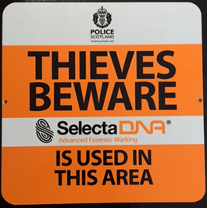

No Cold Calling Zones
- Any community organisation wishing to refresh their zone (those with the old Lothian and Borders Police signs) or interested in setting up a new zone should contact their local community policing team.
https://www.scotland.police.uk/secureforms/contact/


CAT Update:
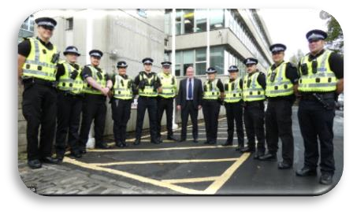

ROAD SAFETY AND ROAD CRIME
Throughout August SBCAT have continued with mobile patrols and static checks in the Scottish Borders, and also helped at the Flodden Ride out. Hand Held speed gun checks were carried out at a number of places including the Mart at Newtown St Boswells, Eyemouth and Coldstream, with a number of drivers being warned. Of note, a male was charged after making off from police with Failing to Stop, Dangerous Driving, Disqualified Driving, No Insurance, and Failing to provide a Sample.

PARKING TICKETS
25 parking tickets were issued throughout the Scottish Borders in August. Parking issues were also addressed in Ayton, Chirnside and Coldstream.

DRUG ENFORCEMENT
During August SBCAT executed one search warrant in relation to misuse of drugs and recovered a large amount of cannabis edibles. SBCAT have also assisted with enquiries for Merseyside police in the Hawick area, and conducted subsequent community reassurance patrols.

ANTISOCIAL BEHAVIOUR
Patrols continue in the Galashiels and Peebles area to address youth disorder. In particular issues at the Old College Building on Melrose Road, Galashiels, have been resolved through a combination of youth warning letters and improving security to the building. We have also given attention to the playground at Newtown St Boswells, the Lauder Common Riding and Peebles Agricultural Show.

RURAL / ACQUISITIVE CRIME
Following some high value mountain bike thefts in Peebles, positive lines of enquiry were identified and one of the culprits identified from CCTV. A warrant was obtained by SBCAT and executed in Gorebridge, with the recovery of evidence within. The male was charged with the theft of the bikes and held in custody for court.

ARREST WARRANTS
SBCAT proactively search for persons wanted on warrant and arrested five wanted persons in August.

Feedback from a meeting/contacting your Community Policing Team
Anyone with information relating to any criminal activity can contact Police Scotland by dialling 101 or alternatively anonymously by calling
CRIMESTOPPERS on 0800 555111.
Should the Community Council wish to discuss any matters highlighted in the report, please contact:
TweeddaleEastCPT@scotland.pnn.police.uk
TweeddaleWestCPT@scotland.pnn.police.uk
We will endeavour to provide you with this information, however some information is sensitive and as an organisation we have to ensure compliance with GDPR.

